Members Profile Schema for
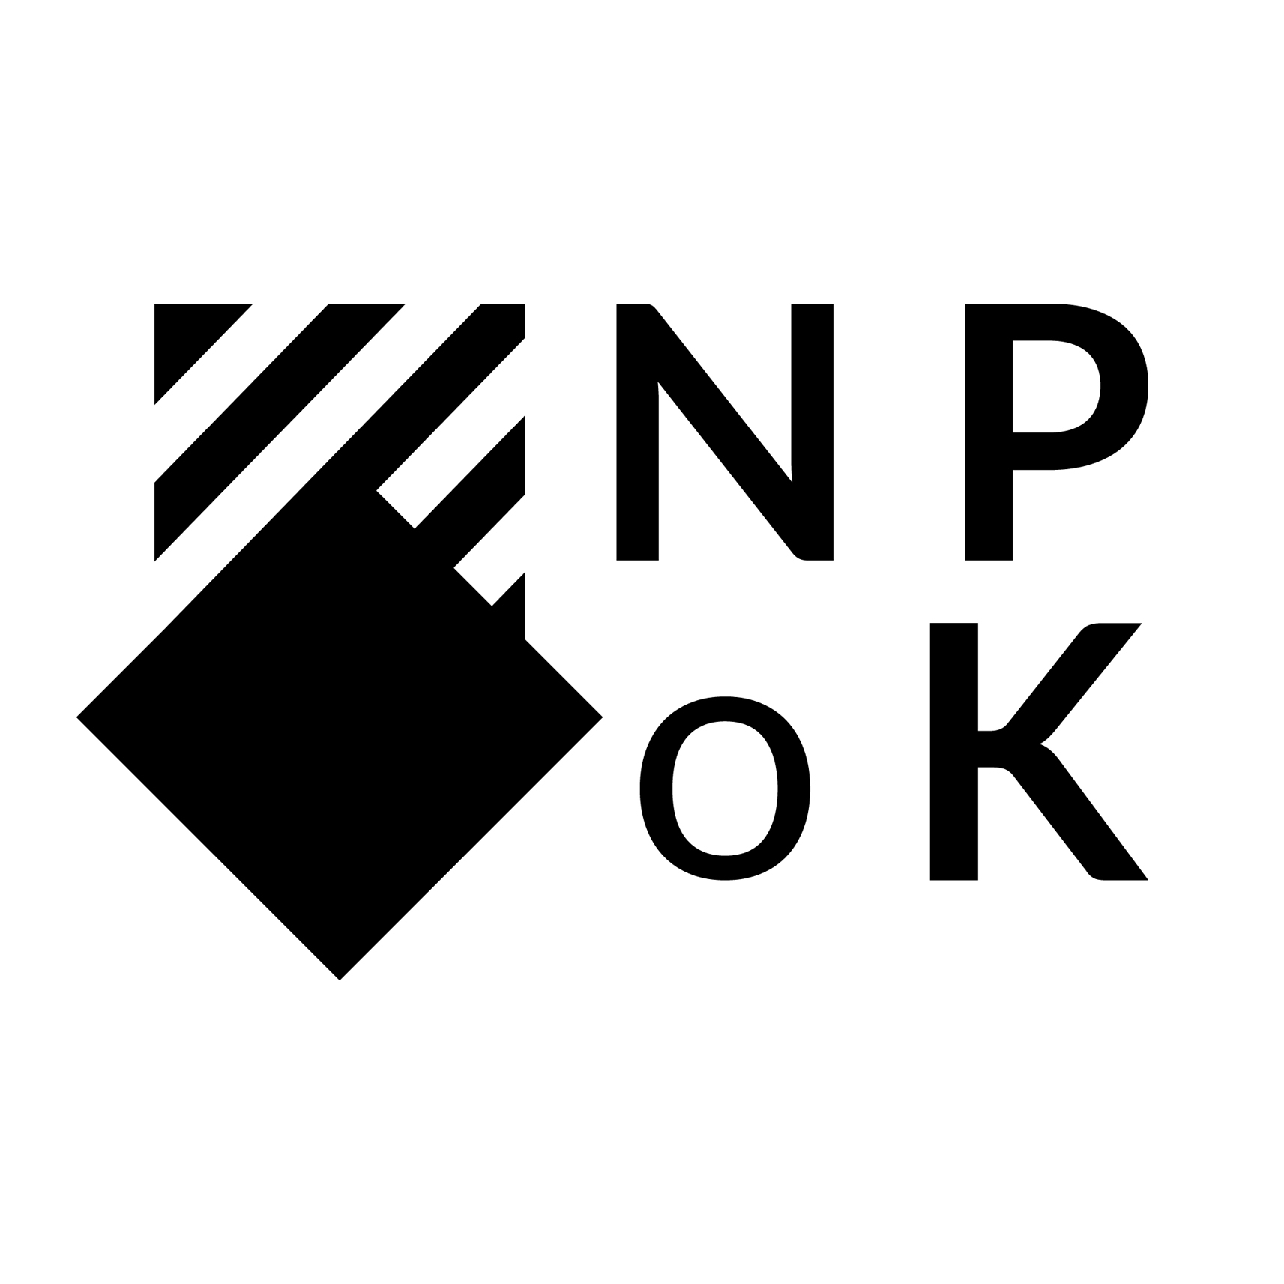
NPoK Norwegian Polish Culture Organisation

Please fill in those information which will represent Your artistic
practice the best way

1.Name and surname
2.Profession
3.Medium of choice

4.Education

5.Artist statement or a Quote up to 100 words

6.Art BIO up to 500 words including: exhibitions, collaborations, symposia all professional activities in order form newest til oldest not older than last 10 years)

7. 5-10 pictures of work ( not older than last 5 years) max 2MB per picture in jpg format
8. Portrait picture in jpg format max 2MB

9. Media:

- Website adress (https)
- Instagram address (https and @)
- Facebook (https and @)
- Tiktok (https and @)
- Pintrest (https and @)
- Other

10. Attachments

- CV in extra pdf file max 10MB
- Portfolio in extra pdf file 10MB
- Publications in extra pdf file 10MB

Please provide information in english, extra in Polish or Norwegian
Please send email with attachments to npokorg@gmail.com
If the files are large please upload them via wetransfer.com

